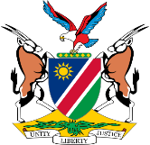
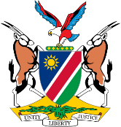
REPUBLIC OF NAMIBIA
BUSINESS AND INTELLECTUAL PROPERTY AUTHORITY (BIPA)
INDUSTRIAL PROPERTY ACT, 2012
Form No. TM 8
Registrar's Office, Republic of Namibia
Request for Renewal
Form No. III.G

REQUEST FOR RENEWAL
(Section 158(1) and regulation 111(2))

For Official Use:
Request received on:

Official Date Stamp
Trade Mark Registration No. Filing Date

Class(es)

Name of Proprietor:

We would like to request that the abovementioned Trade Mark be renewed for a further period of 10 years in the following Class(es):

Owner/Agent
Name

Address
Telephone No. E-mail Address

Signed this day of 20 .

Signature (Owner/Agent)

