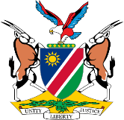
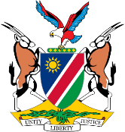
REPUBLIC OF NAMIBIA
BUSINESS AND INTELLECTUAL PROPERTY AUTHORITY (BIPA)
INDUSTRIAL PROPERTY ACT, 2012
Form No. TM 17
Registrar's Office, Republic of Namibia
Recording of Change in Ownership
Form No. III.L

3333

APPLICATION FOR REGISTRATION AS REGISTERED USER
(Section 171(1) and regulation 117(1))
For Official Use

Received on:

In the Matter of:

Trademark Applicant/ Registration No.

Applicant(s)/Owner(s)

Name

Address
Telephone No. E-mail Address

Request

Application is hereby made by the above applicant who is the proprietor of Trade Mark(s) No(s):
______________________________________
registered in classes ________________________________in respect of (goods/services) __________________________________
that ______________________________________________(Registered User) of (address) _________________________________who hereby joins in the application, may be registered as the Registered User of the abovementioned trade mark(s) in respect of (good/services) ________________________________________subject to the following conditions or restrictions:
___________________________________________________________________________
___________________________________________________________________________
_____________________________________________________________________________

The proposed permitted use is to end on the ______________day of _______________________20____, / Proposed /permitted use is without limit of period.

The Proposed Registered User will/will not be the sole user.

Address for Service:

Additional Information

The following items accompany this Form:
Evidence that the proposed user is authorized to use the trade mark by the registered owner of the trade mark

Fees

Other (specify)

Signed this__________day of____________________20_________.

Signature (Applicant/Agent)

