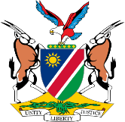
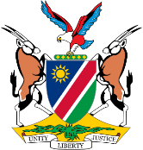
REPUBLIC OF NAMIBIA
BUSINESS AND INTELLECTUAL PROPERTY AUTHORITY (BIPA)
INDUSTRIAL PROPERTY ACT, 2012
Form No. TM 14

Registrar's Office, Republic of Namibia
Request to Dissolve Association Between Two or More Associated Marks
Form No. III.B

APPLICATION FOR DISSOLUTION OF ASSOCIATED TRADE MARKS
(Section 162(5) and regulation 115(1))

For Official Use:

Official Date Stamp

Trade Marks Registration Nos: ___________________________________________________________________

Classes: _____________________________________________________________________________________

Application is hereby made that the association of the above-numbered trade marks registered in the name of

________________________________________________________________________________ be dissolved and the register be amended accordingly with effect______________________________

Registration is in respect of the following goods and/or services, listed under the applicable classes of the International Classification

I/We, ____________________________________________________________________ give notice of my/our request that the association between the above-mentioned marks be dissolved from (date)
in respect of the goods or services listed under the applicable classes of the International Classification. The grounds for this request are as follows:

Applicant/Agent

Name

Address

Telephone No. E-mail Address

Fees accompany this Form.

Signed this day of 20 .

Signature (Applicant/Agent)

