

MITSMED-ICSF
Name Reservation User Guide

Version 1.000


Prepared by Ecquaria Technologies Pte Ltd

Document Acceptance
ICSF NAME RESERVATION USER GUIDE APPROVAL FORM
MITSMED File Ref : PRN00866
SCE File Ref : 2019/NAM/ICSF/0001

Date : 3 April 2019

Programme Name : INTEGRATED CLIENT SERVICES FACILITIES PROJECT FOR NAMIBIA INVESTMENT CENTRE, MINISTRY OF INDUSTRIALIZATION, TRADE AND SME DEVELOPMENT NAMIBIA

This ICSF Name Reservation User Guide (Version 1.0) is prepared by: ICSF Implementation Team and endorsed by:

___________________________ 3 April 2019
Mr Soh Chze Keong Date
Project Manager, Ecquaria Technologies Pte Ltd

This ICSF Name Reservation User Guide is approved by:

___________________________ ______________
Ms. Angela Dau Pretorius Date
Ministry of Industrialization, Trade and SME Development Deputy Director

About this Document
Document Version History

Version | Description | Date Created | Prepared By
1.000 | 1st Version | 28 Feb 2019 | Choo Rui Bin

Document Distribution History

Document | Distribution Channel (Electronic / Hardcopy) | *Copy No. | Distributed To | Distribution Date
1.000 | Hardcopy | 1  2 | - System Owner  - Implementation Team PM

Table of Contents
1 Overview 5
2 Accessing the e-service 5
3 Application process 7
3.1 Service Description page 7
3.2 Fill Form page 9
3.3 Document Upload page 13
3.4 Confirmation Page 14
3.5 Acknowledgment Page 15
4 Payment process 16
4.1 Accessing the payment service 16
4.2 Verifying the payment amount 17
4.3 Uploading proof of payment 19
5 Following up on your application 23
5.1 Status – Approved 24
5.2 Status – Rejected 26
5.3 Status – Pending Amendment 26

Overview

This document provides a step-by-step guide to the usage of the “Name Reservation” e-service under the BIPA agency in ICSF.

This e-service allows you to reserve your business name with BIPA. You are required to submit a minimum of 2 proposed names so as to increase the chances of one of your proposed names receiving approval.

Your proposed name must not be already existing in the BIPA database and should not contain any offensive words or vulgarities in any language. There will be a validation check on this during the form filling process. Following submission, you will receive immediate in-principle approval for your proposed names. Thereafter, you are able to instantly proceed to registering your business.

For full approval, human intervention from the BIPA agency officer is still required. However, it is almost certain that your in-principle approved proposed names will be granted full approval, as long as it does not flout any of BIPA’s regulations.

Accessing the e-service

First, log in to the Citizen Centre by clicking the following link https://services.icsf.gov.na/egov/.

Click Continue and login by entering your user ID and your Password.

From the landing page, select the “Digital Services” dropdown menu in the top banner and click on the “Name Reservation” option.

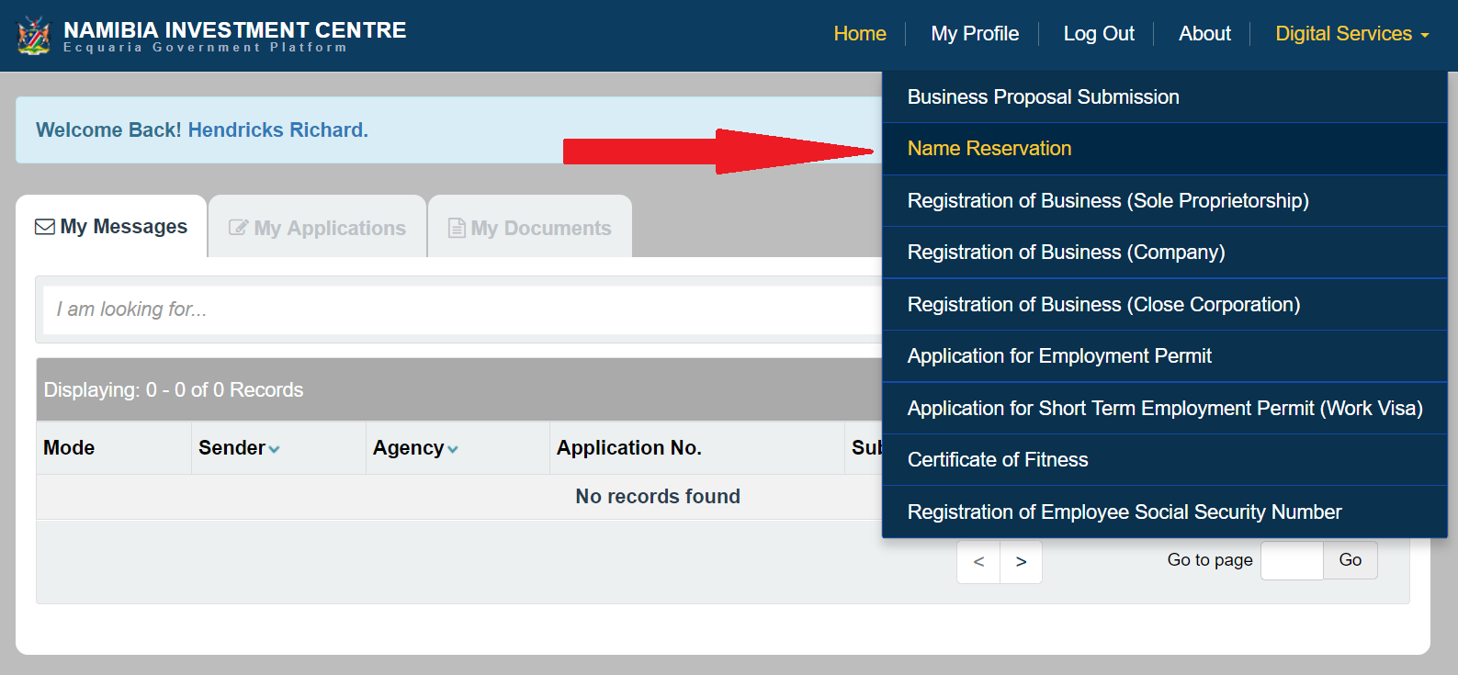
Figure 2.1: Accessing the e-service from the Citizen Centre

Application process

Service Description page

The first page of the e-service is the Service Description page. Here, you can get information such as the required documents that has to be prepared in advance, the estimated turnaround time, the service fee and a contact person.

An estimated timeframe for completion will also be provided for your benefit.
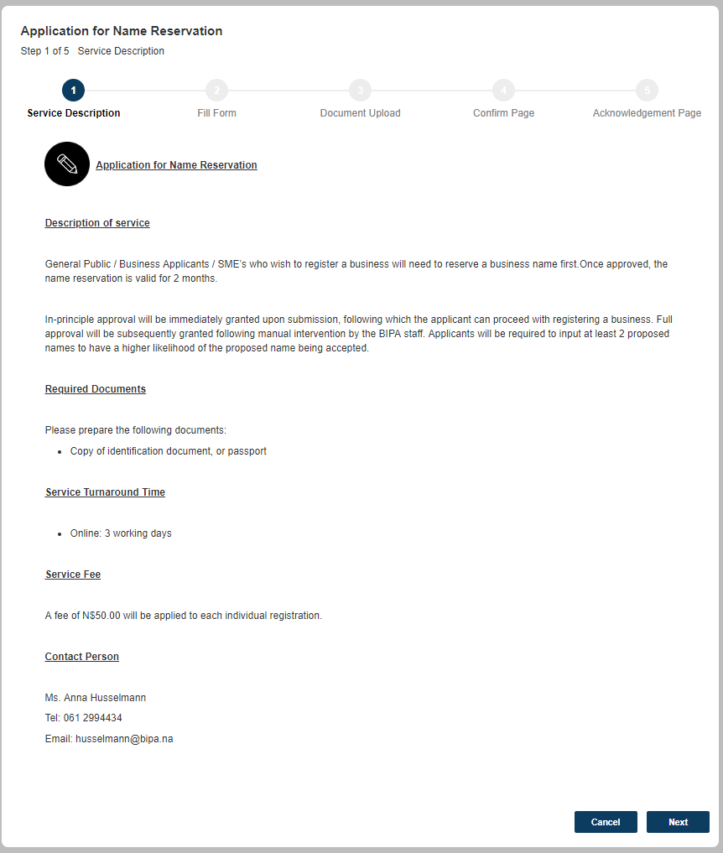
Figure 3.1.1: Service Description page
Once you are ready to proceed, click on the  button at the bottom of the page.

Fill Form page

In this page, you are required to input the application information into the respective form fields. Fields that are marked mandatory must be filled, else the application would not be able to proceed.

The form is divided into 3 sections:
- Applicant Information
  - Postal Address of Applicant
- Business Information
- Proposed Names

Applicant Information
The “Applicant Information” section contains fields on your basic information.

Most of these fields would have been pre-populated based on your profile information, if available.

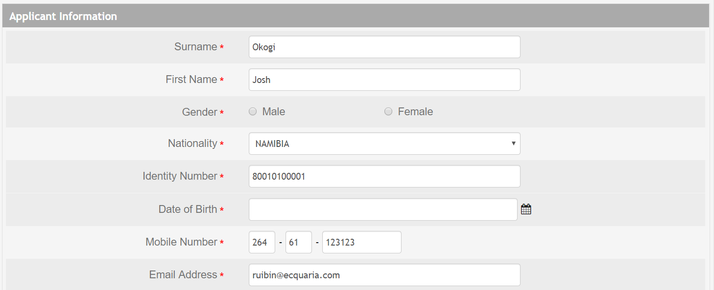
Figure 3.2.1.1: Applicant Information section
If you are a foreigner, then the “Passport Number” field would be displayed instead.

Figure 3.2.1.2: Applicant Information section, if foreigner

Field | Description
Surname | Surname of applicant
First Name | First name of applicant
Gender | Gender of applicant
Nationality | Nationality of applicant
Identity Number | Identity number of applicant, if local
Passport Number | Passport number of applicant, if foreigner
Date of Birth | Date of birth of applicant
Mobile Number | Mobile number of applicant
Email Address | Email address of applicant

Postal Address of Applicant
In this section, you are required to input your postal address.

This address can only be a local Namibian address.

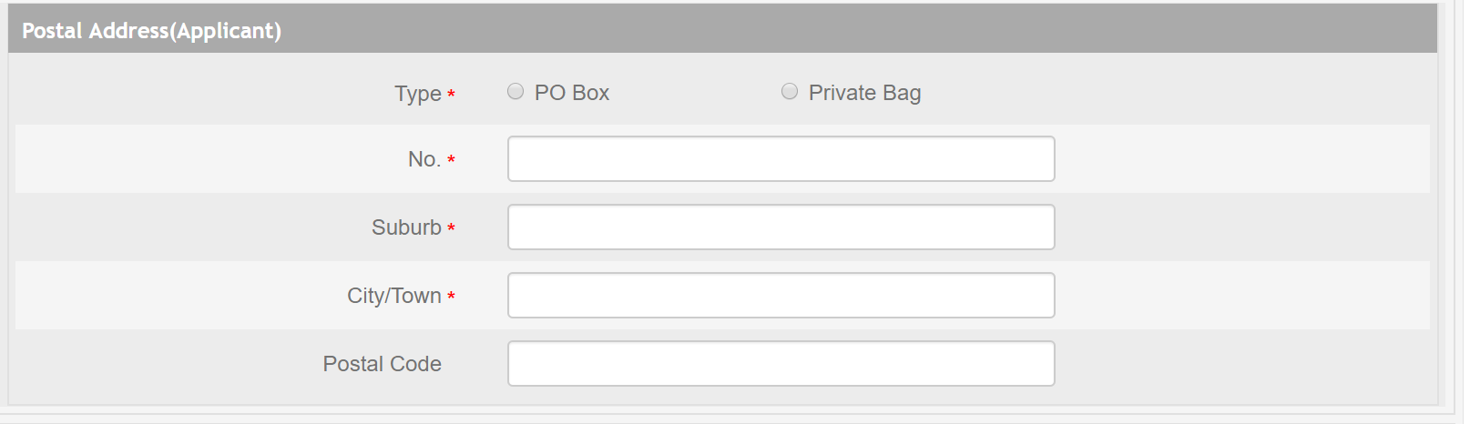
Figure 3.2.1.1.1: Postal Address of Applicant
Field | Description
Type | Specify whether the postal address is a PO Box or Private Bag
No. | Number of PO Box or Private Bag
Suburb | Name of the suburb in the city/town
City/Town | Name of the city/town in Namibia
Postal Code | Postal code of the location

Business Information

In this section, you are required to provide some basic information on your business. The information input here cannot be further edited at a later stage, i.e. the details will carry forward to the next step where you submit a business registration application.

You are also required to specify the type of your business associated to this business name reservation – whether it is a sole proprietorship, close corporation or company.

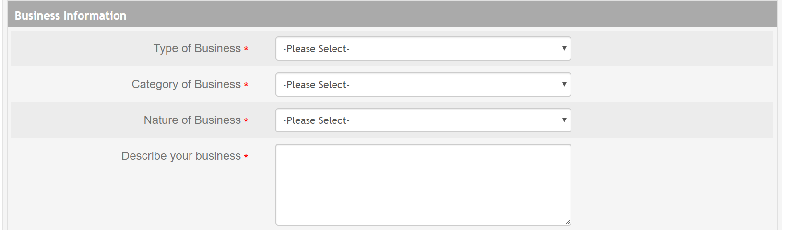
Figure 3.2.2.1: Business Information section
Field | Description
Type of Business | Specify whether your business is a sole proprietorship, close corporation or company.
Category of Business | Industry that your business operates in.
Nature of Business | Specific type of your business’ nature.
Describe your business | Provide a brief description of your business and its processes and workings.

Proposed Names

In this section, you will submit your proposed names for your business and your reason behind choosing them.

Your name can be reserved as the proposed name for your business, the translated form of another business name, or the shortened form of another business name.

If your proposed names here are in a foreign language, you are required to provide a translation of the names to English.

You are required to submit a minimum of 2 proposed names so as to have a higher chance of approval.

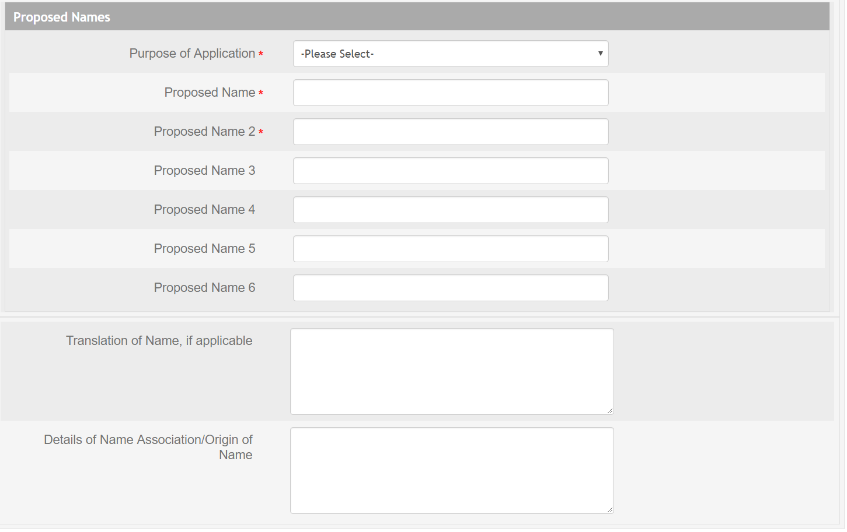
Figure 3.2.3.1: Proposed Names section
Field | Description
Purpose of Application | Specify whether the names are to be reserved as a proposed name, shortened form or translated form.
Proposed Name | Your first proposed name
Proposed Name 2 | Your second proposed name
Proposed Name 3 | Your third proposed name
Proposed Name 4 | Your fourth proposed name
Proposed Name 5 | Your fifth proposed name
Proposed Name 6 | Your sixth proposed name
Translation of Name, if applicable | Provide a translation of your proposed names if they are in a foreign language.
Details of Name Association/Origin of Name | Explain your reason behind choosing your proposed names

Anytime you wish to save your progress and continue your application at a later stage, click on the  button.

Once you are ready to proceed, click on the button at the bottom of the page.

Document Upload page

The next step in the application process will be to upload the supporting documents for your application.

There is only one document required for this application – a copy of your ID, if you are a local Namibian, or passport document, if you are a foreigner.

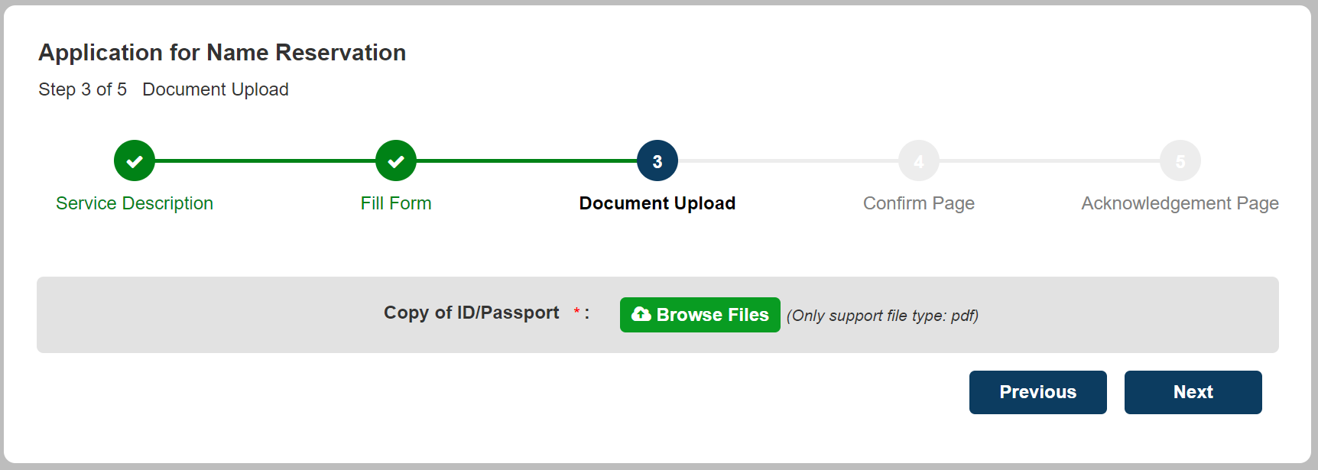
Figure 3.3.1: Document Upload page
Once you are ready to proceed, click on the button at the bottom of the page.

Confirmation Page

The Confirmation Page is for you to review all the information that you have entered and to ensure that they are correct and accurate.

If you wish to make any amendments, click on the  button to be directed back to the Fill Form page.

If you are satisfied with all your input information, check the declaration checkbox. This serves as your legal certification that the application details are true and correct as of your knowledge.

Figure 3.4.1: Declaration checkbox

Then, click on the button to proceed.

Acknowledgment Page
After the declaration is made and the button is clicked on the Confirmation Page, the application will be placed into a “holding pool”. The final action is to make the requisite payment for the application before it will be formally submitted to the BIPA backend system.

The application number displayed on the page can be used to track the status and progress of your application.

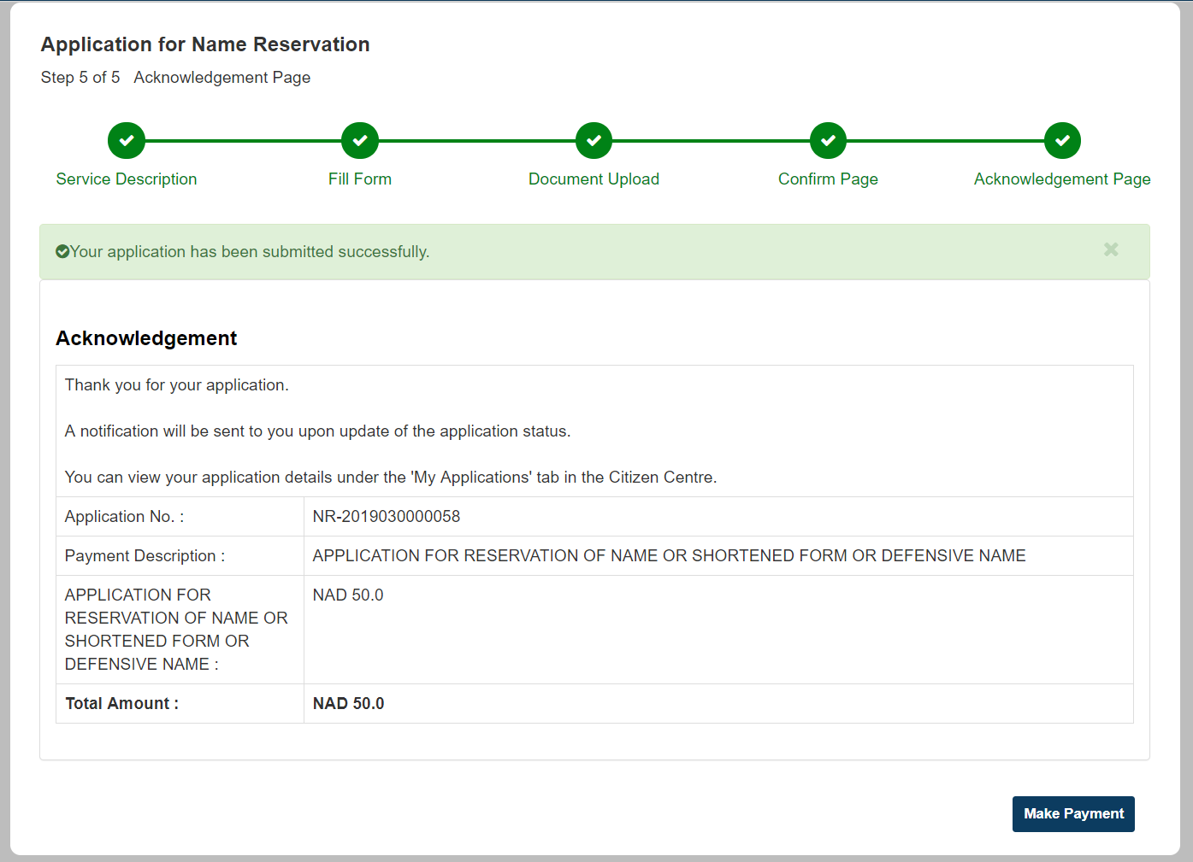
Figure 3.5.1: Acknowledgment Page

Payment process

After the application form is completed, the final action will be to make payment for the application. The payment process can either be:
- Done immediately after completing the application form – access from the Acknowledgment Page
- Postponed after completing the application form till a later stage – access from the Citizen Centre

Accessing the payment service

From the Acknowledgment Page

To make payment for the application immediately after completing the application form, you can click on the 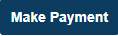 button on the Acknowledgment Page as displayed above in Figure 3.5.1.

That will immediately redirect you to the payment service.

From the Citizen Centre

If you had completed the application form portion but decided to continue the payment process at a later stage, you can access and continue your application from the Citizen Centre. It will be displayed with a “Pending Payment” status under the “My Applications” tab.

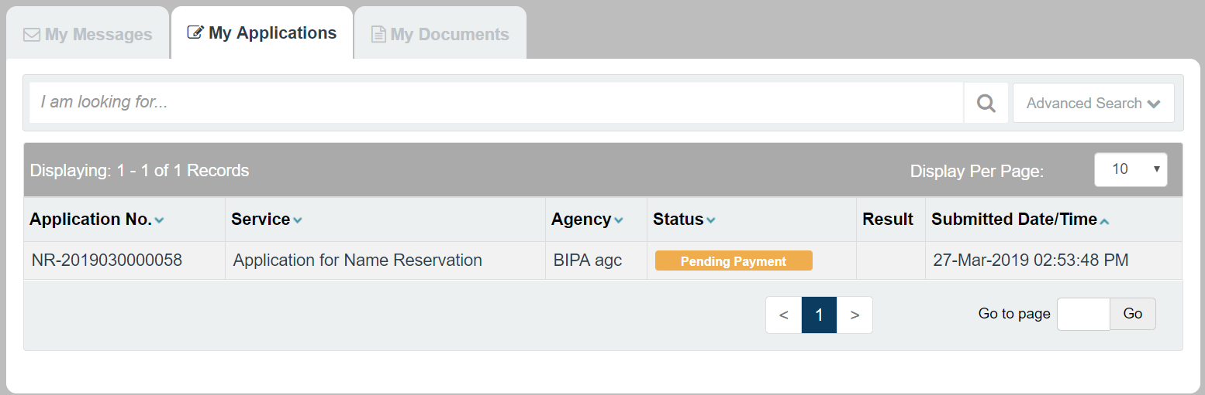
Figure 4.1.2.1: Application with “Pending Payment” status in the Citizen Centre
Clicking into the application will display the following details page.
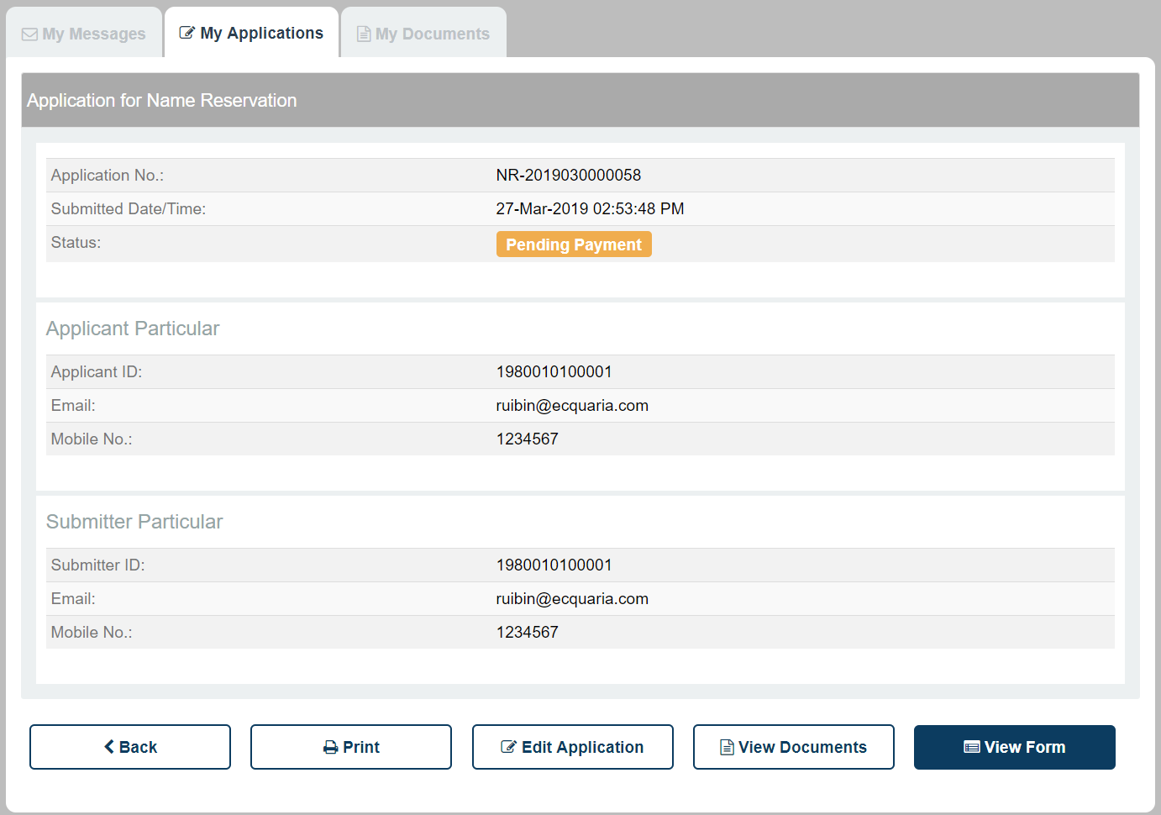
Figure 4.1.2.2: Details page of an application with “Pending Payment” status

Clicking the  button will then re-direct you to the payment service.

Verifying the payment amount

The first page of the payment service contains the application number and the amount to be paid.

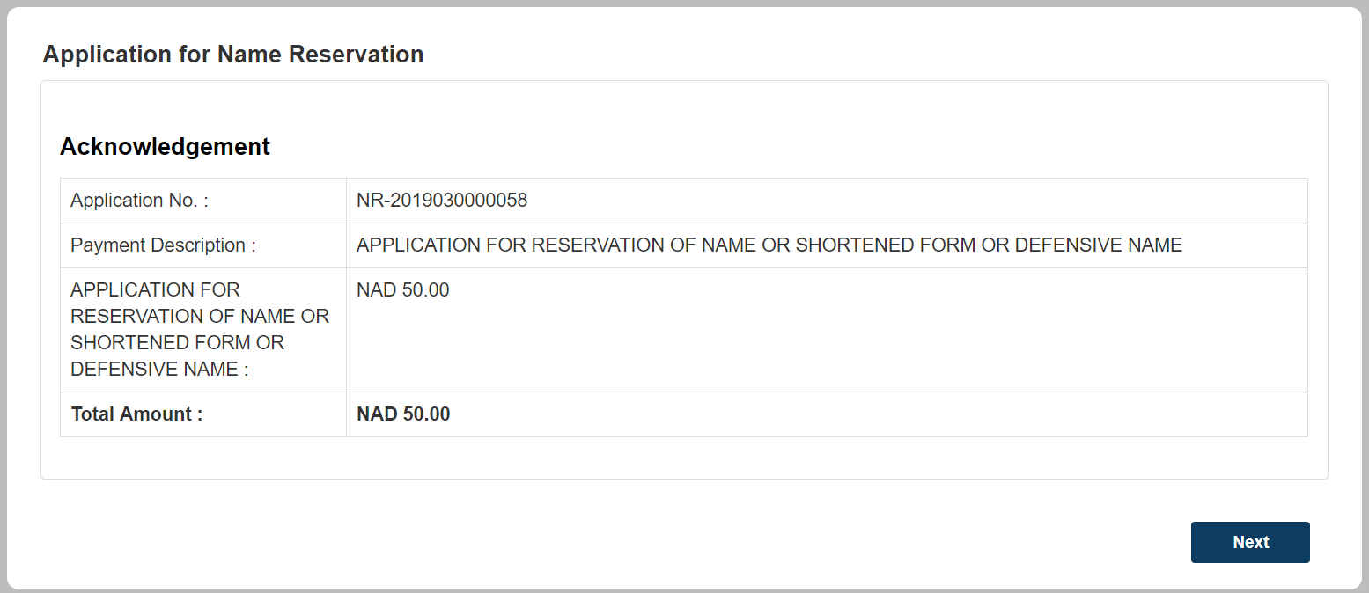
Figure 4.2.1: Payment Service – Acknowledgement on the payment amount
There is only the manual payment method available. Clicking on the button will bring you to a confirmation page, where the transaction reference number is listed.

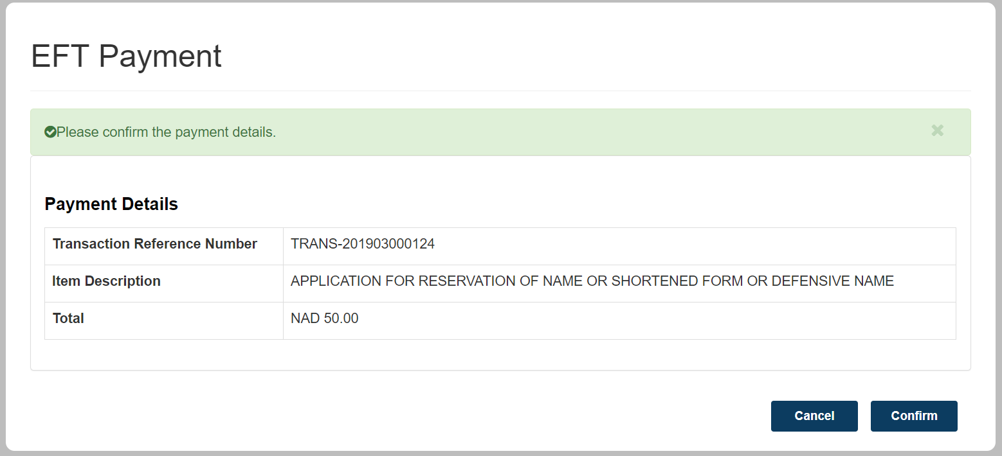
Figure 4.2.2: Payment Service – EFT Payment Confirmation Page
Clicking on the  button redirects you to the next page, where the payment slip is displayed.

You may choose to print out this payment slip and quote it as a reference number while you perform the payment, either via cash or EFT.

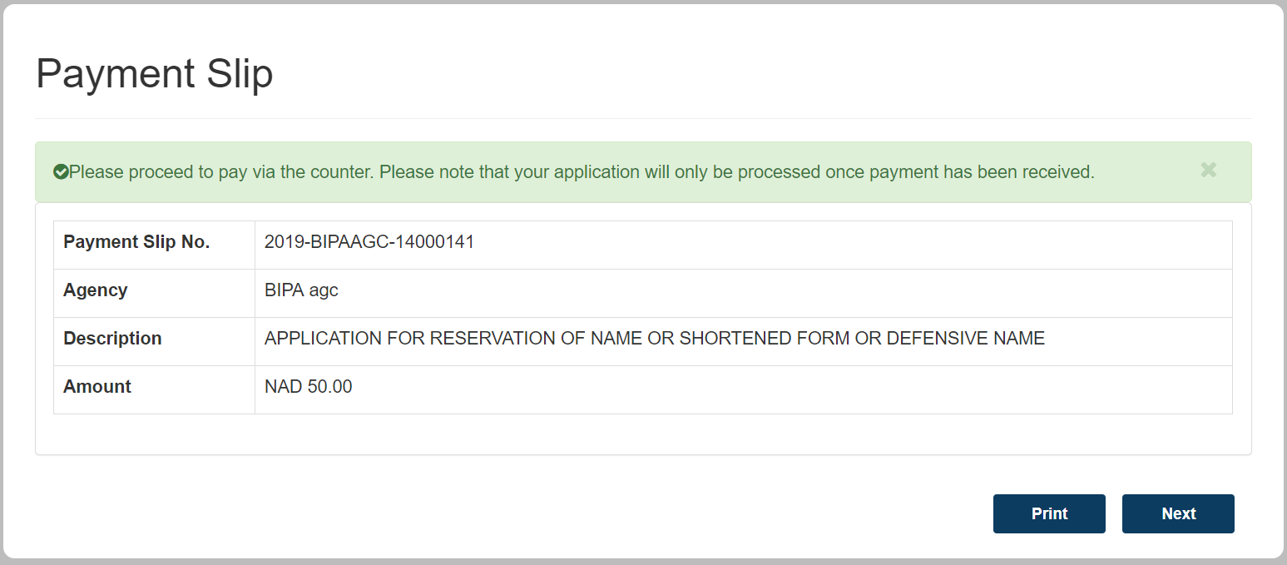
Figure 4.2.3: Payment Service – Payment Slip
Clicking the button ends the flow for the first part of the payment service. At this stage, you will have a payment slip number, which you can quote while making your payment via a cash transfer or EFT.

Uploading proof of payment

After you make your payment, you should receive a document that verifies the transaction. You are then required to upload this document representing your proof of payment back into ICSF.

Click on the “My Applications” tab in the Citizen Centre. The status of your Name Reservation application remains at “Pending Payment”.

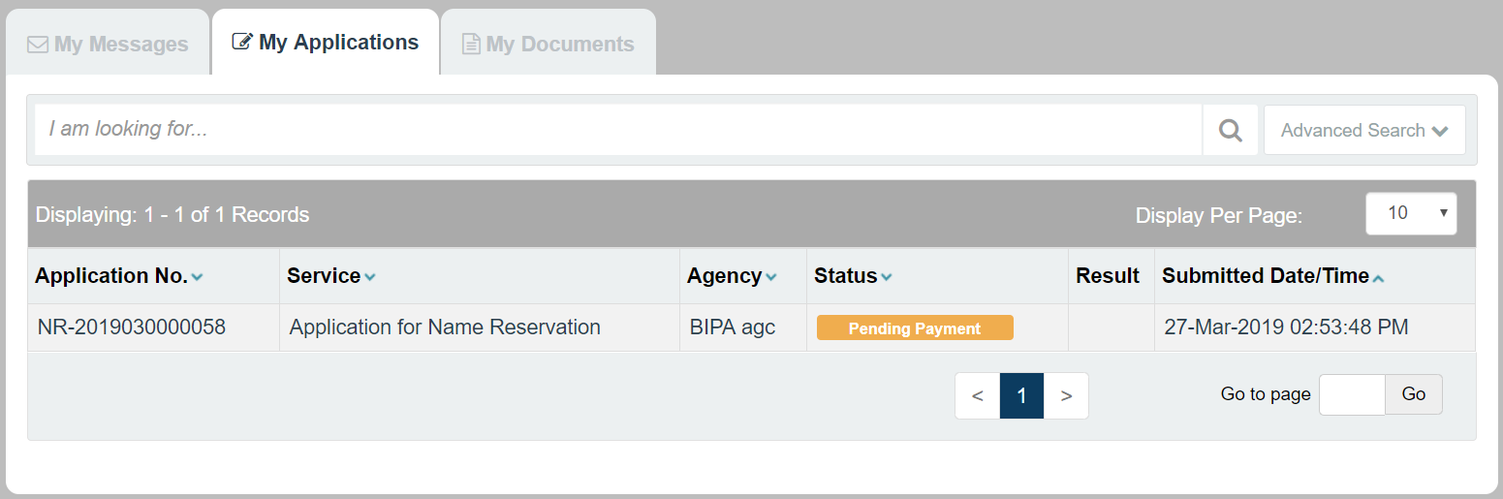
Figure 4.3.1: Application with “Pending Payment” status in the Citizen Centre
Clicking into the application will display the following details page.

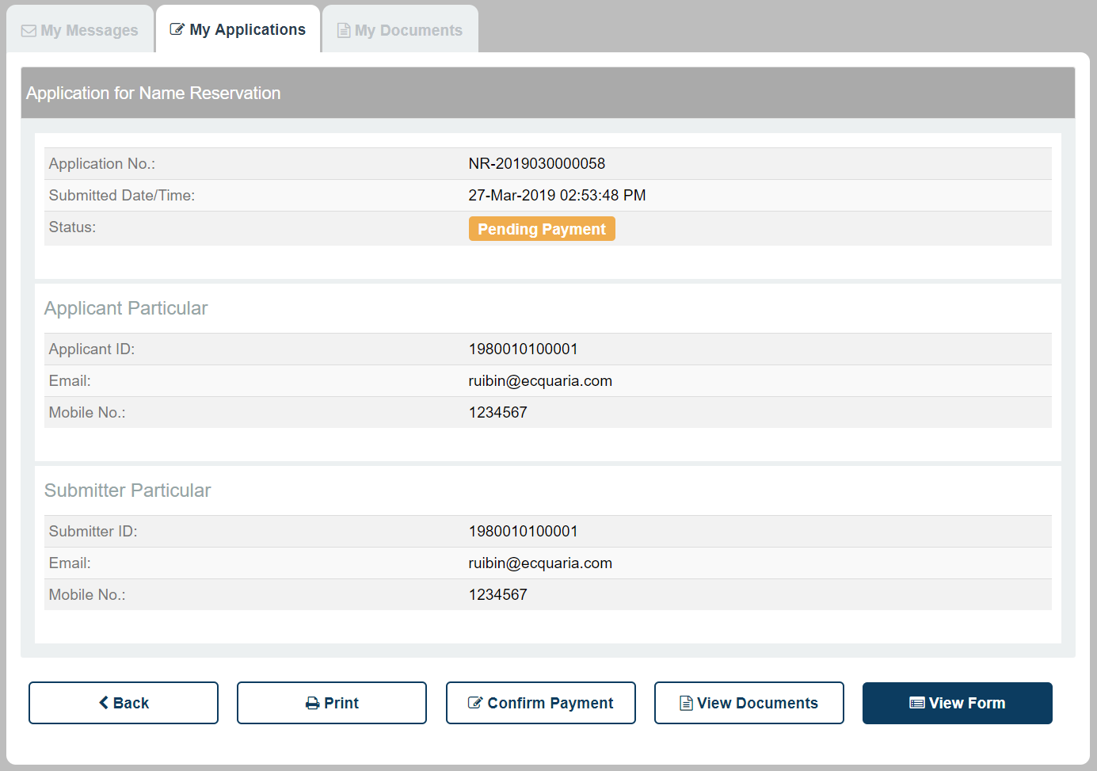
Figure 4.3.2: Details page of an application with “Pending Payment” status

Previously, in Section 4.1Error! Reference source not found., the middle button was a button.

Now, it is replaced by a  button. Clicking on this button will redirect you to the “Update Payment Status” page.

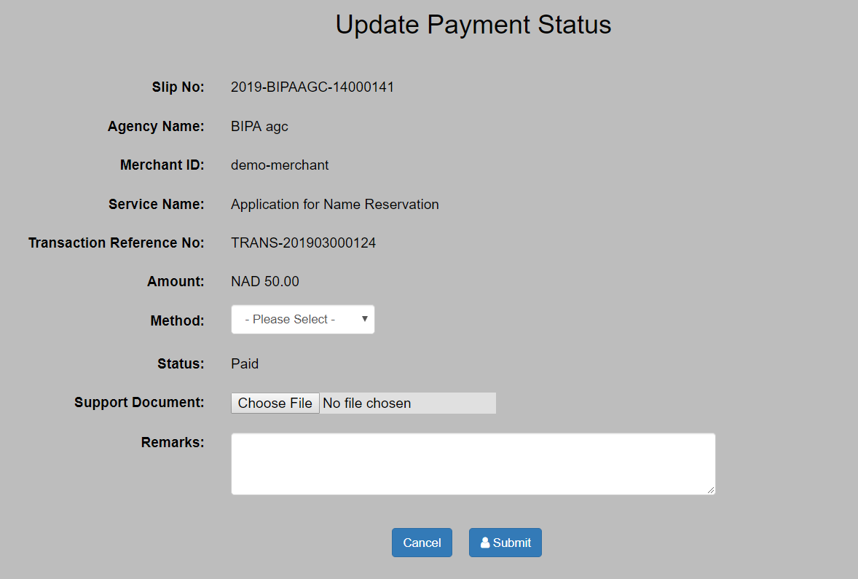
Figure 4.3.3: Update Payment Status page

In this page, there are 3 fields for you to input:
- Method
  - Select either cash or EFT
- Supporting Document
  - Your bank receipt/other document showing proof of payment
- Remarks
  - Personal remarks regarding your payment

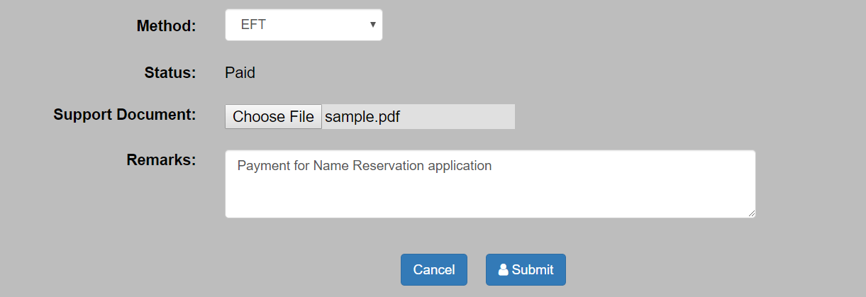
Figure 4.3.4: Sample input in the Update Payment Status page
After filling in the required fields with valid input, click on the  button to submit your application to the BIPA backend.

You will be redirected back to the Citizen Centre. Click on the “My Applications” tab to view your application with its updated status of “Pending Payment Check”.

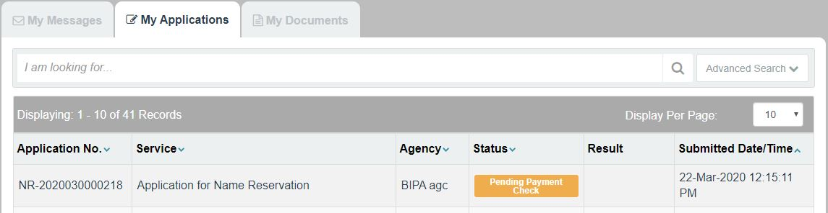

Click on the “My Applications” tab to view your application with its updated status of “Pending Approval”.

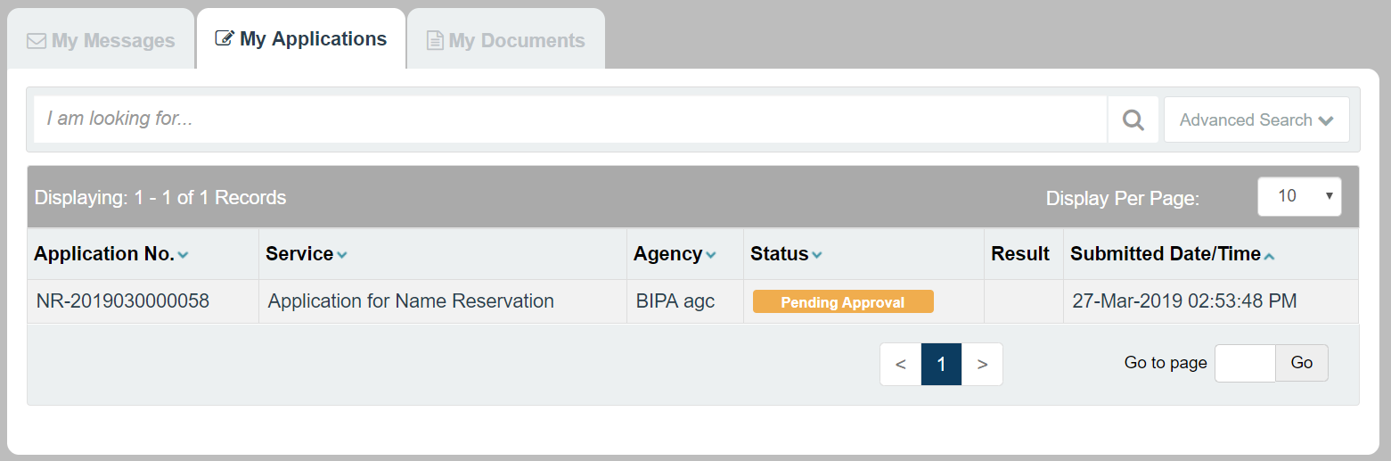
Figure 4.3.5: Application with “Pending Approval” status in the Citizen Centre

Following up on your application

After the application is submitted, you can continue to track its progress and status updates in the Citizen Centre.

In the Citizen Centre, navigate to the “My Applications” tab. Your application will be displayed there, along with an accompanying status.

Figure 5.1: “My Applications” tab in the Citizen Centre

Clicking into the application will display the following page.

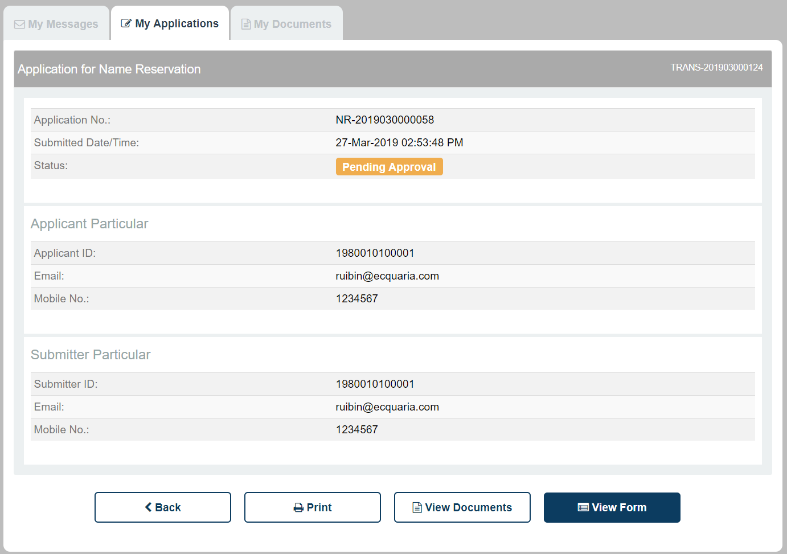
Figure 5.2: Details of my application
To view the form details that you have input, click on the  button.

To view the attached documents, click on the  button.

Upon a change in the status of your application, you will receive a notification – either via e-mail or post, depending on the selected option in the form.

Status – Approved

Upon approval of your application, it will be displayed under the “My Applications” tab in the Citizen Centre as follows.

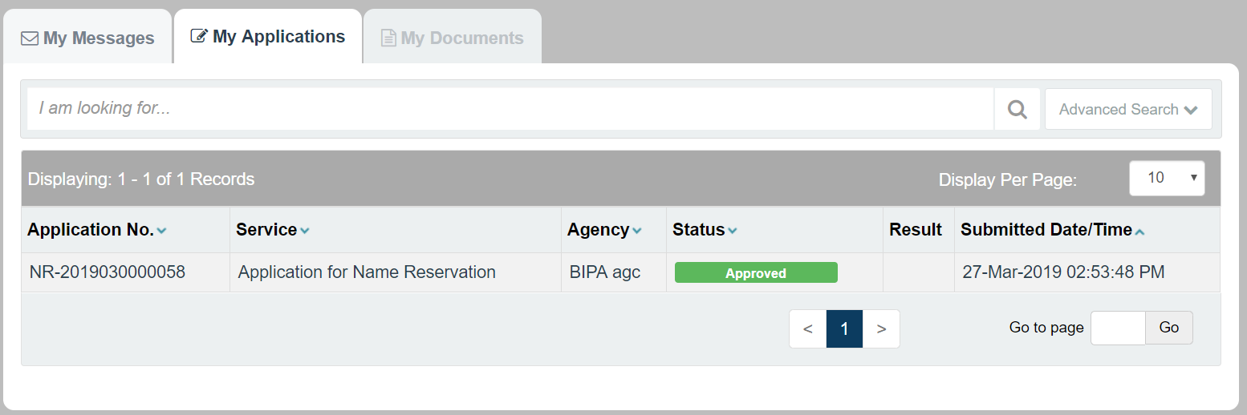
Figure 5.1.1: Application with “Approved” status in the Citizen Centre
Clicking into the application will display the following details page.
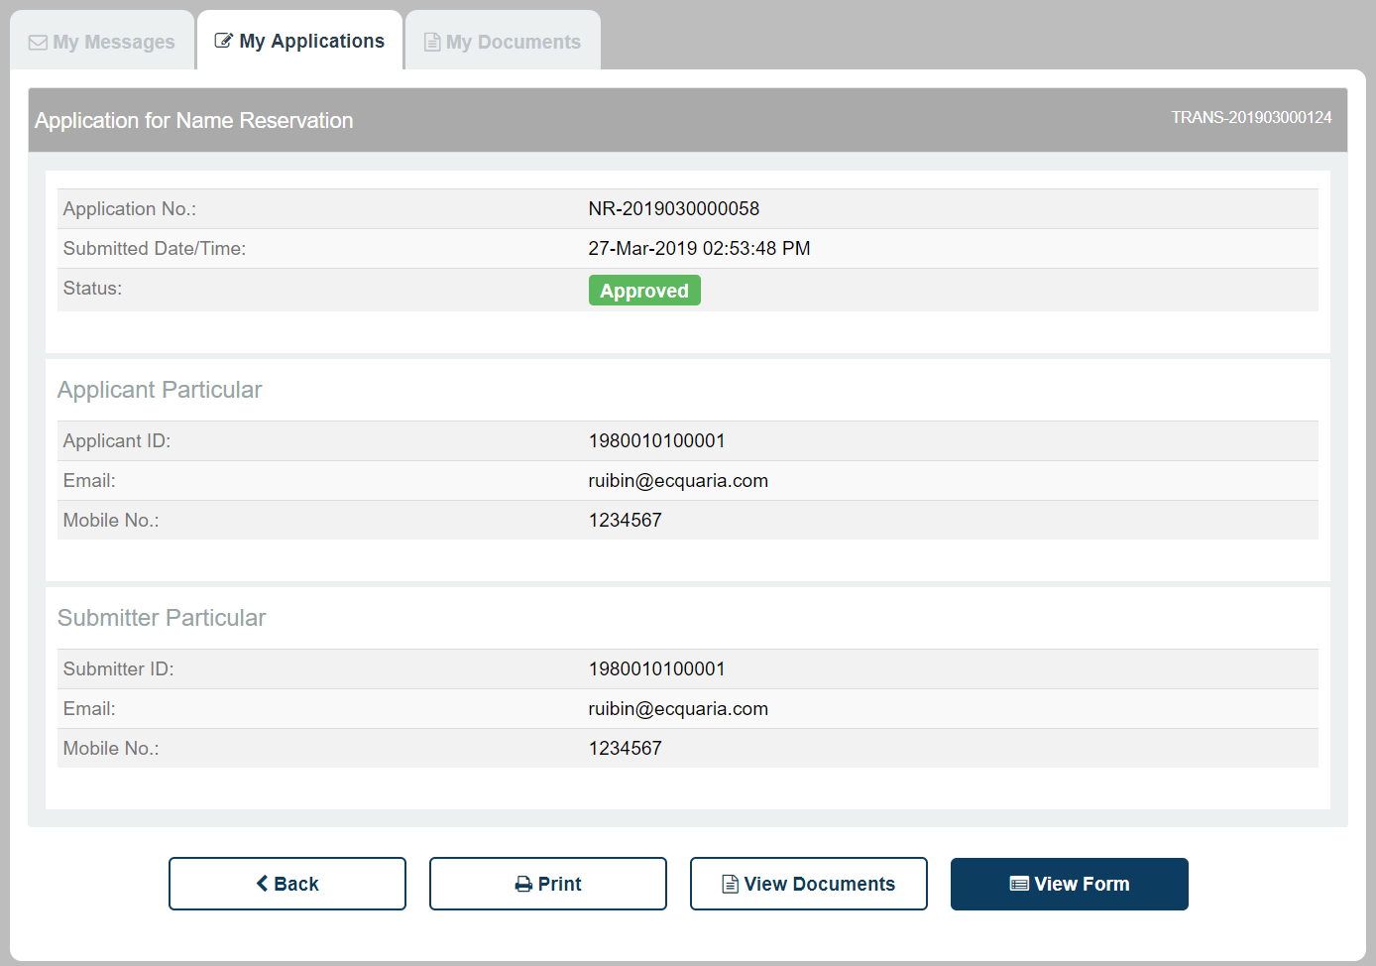
Figure 5.1.2: Details page of an application with “Approved” status

As your application has already been approved, no further action will be required.

Status – Rejected

If is your application is rejected, it will be displayed under the “My Applications” tab in the Citizen Centre as follows.

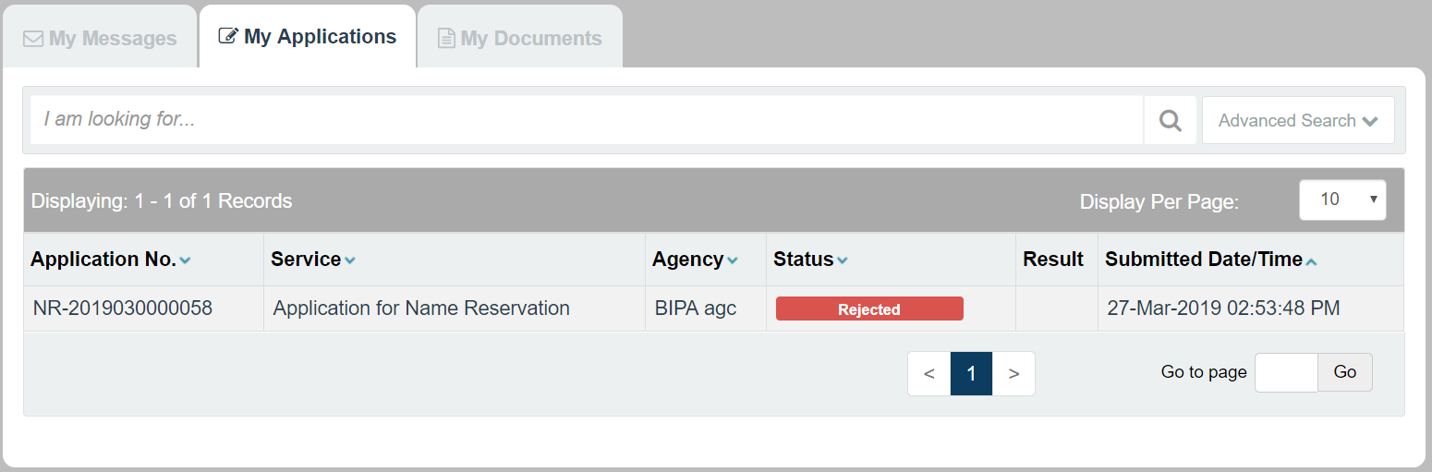
Figure 5.2.1: Details page of an application with “Rejected” status

You will also receive an e-mail notification notifying you of your application result. This e-mail will contain the backend officer’s comments on why your application has been rejected.

If you wish to re-submit your application, you will have to restart from the beginning.

Status – Pending Amendment

An application’s status can be updated to “Pending Amendment” by the agency staff for a variety of reasons. Some plausible reasons include:
- Insufficient information provided, i.e. request for additional details
- Typo mistakes in the application form
- Any queries the staff might have

The backend officer’s comments will be included in your email notification, as well as displayed under the “My Messages” tab in the Citizen Centre. You may refer to the comments for guidance on the specific details to amend.

If is your application is updated with the status “Pending Amendment”, it will be displayed under the “My Applications” tab in the Citizen Centre as follows.
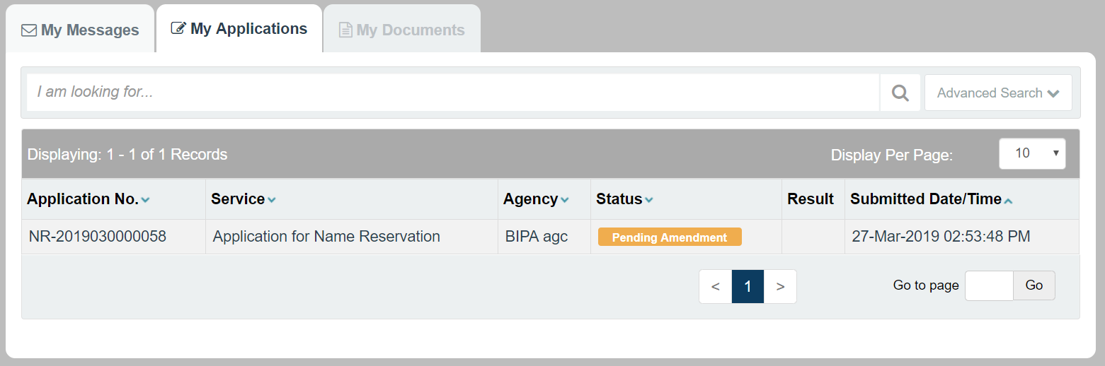
Figure 5.3.1: Application with “Pending Amendment” status in the Citizen Centre

Clicking into the application will display the following details page.

Figure 5.3.2: Details page of an application with “Pending Amendment” status
To amend the application information, click on the  button. This will bring you back to the Fill Form page as detailed in Section 3.2. Note that the form will already be pre-populated based on the information that you had submitted during the initial application.

Thereafter, you can adopt the same sequence of steps as when you were submitting the application. Input or amend the required details in the Fill Form page, upload the documents in the Document Upload page, verify your input information in the Confirmation Page and finally, send it back again for approval.

The application will then be back at “Pending Approval” status.

